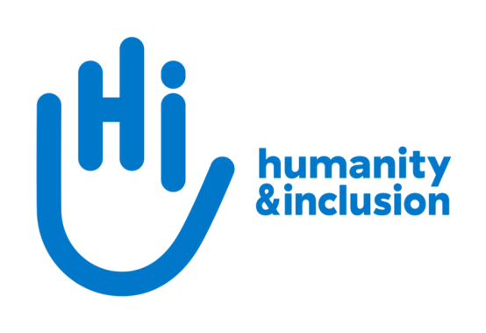

Communications Officer: Armed Violence Reduction

Application pack

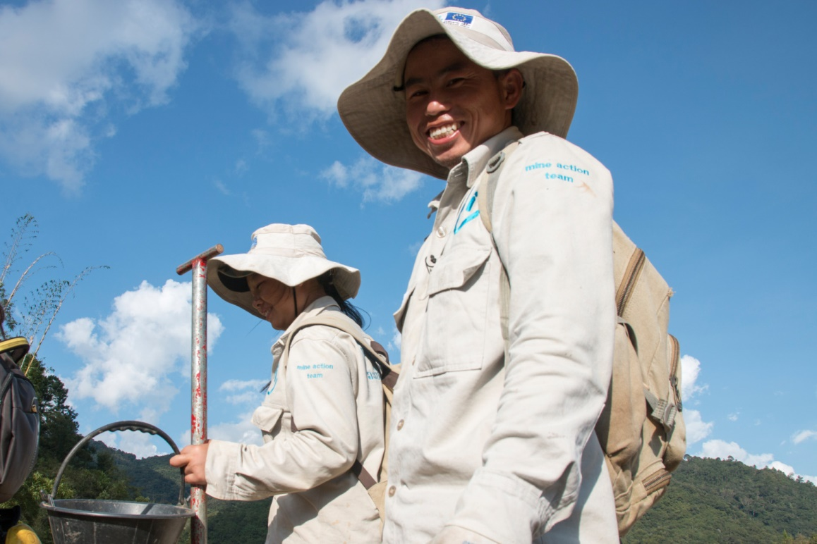

HI de-miners in Houaphan Province, Laos ©N.Lozano Juez/HI

Do you want to improve the lives of people with disabilities and vulnerable people?

Humanity & Inclusion (HI) is an award-winning international development organisation working in situations of poverty and exclusion, conflict and disaster. Our Armed Violence Reduction team works to prevent injury, disability and loss of life through clearance of explosive devices, risk education, research and innovation, advocacy and interventions to support conflict transformation.

We are looking for a Communications Officer to join the team. This exciting position will be responsible for communication of our work in this area, including organising public events and producing compelling content.

About Humanity & Inclusion (HI)

Working alongside people with disabilities and vulnerable populations, we take action and raise awareness in order to respond to their essential needs, improve their living conditions and promote respects for their dignity and fundamental rights.

HI was co-winner of the 1997 Nobel Peace Prize for our campaign for the Mine Ban Treaty. We were also awarded the 2011 Hilton Humanitarian prize in recognition of our contribution to alleviating human suffering and supporting the most vulnerable people.
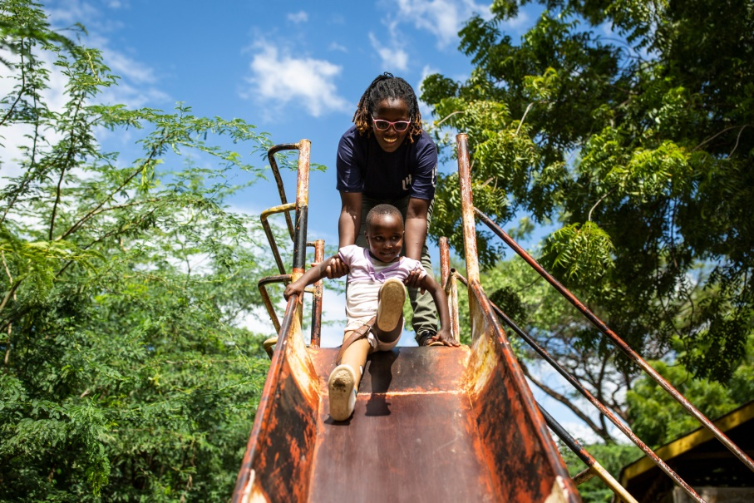
Grace, 5, was born with a congenital disability. She lives in Kakuma refugee camp. Having received a prosthesis from HI, she goes to school and can play like any other child. She wants to be a teacher when she grows up. Here she is with Stella, her HI physiotherapist.

©Patrick Meindhardt/HI

Outraged by the injustice faced by people with disabilities and vulnerable populations, we aspire to a world of solidarity and inclusion, enriched by our differences, and where everyone can live in dignity.

Respect for the rights of people with disabilities has been at the heart of HI’s approach since it was founded in 1982. Over forty years on, our organisation is still working and fighting around the world to improve the living conditions of people with disabilities and other vulnerable people and to ensure that their fundamental rights are respected.

About Humanity & Inclusion UK (HI UK)

HI UK is a member of the Humanity & Inclusion Network, which is comprised of a Federation and eight national associations. As part of the Network, HI UK works towards a common strategy while maintaining a distinct identity as a British organisation. The Federation is responsible for implementing the Network’s social missions in around fifty countries. It operates under the names “Humanity & Inclusion” or “Handicap International”, depending on the country.

HI has an ambitious delivery plan in the UK, as part of our 2016-25 strategy, For More Solidarity and Inclusion in the World.

Equal opportunities policy

HI UK is committed to diversity and inclusion. We recognise that discrimination shapes the opportunities that many people have in society and that people have different needs in order to realise their full potential. Addressing this requires organisations to be proactive in creating environments that encourage the inclusion and development of all. Though we still have a long way to go, inclusion is central to our identity at HI UK and we are strongly committed to the continuous work that it requires.

We are particularly interested in hearing from candidates with disabilities and/or from minority ethnic backgrounds to help make us more representative. If you have a disability and meet the minimum requirements for the role, we will guarantee you an interview.

Employee benefits

- All employees are entitled to 28 days’ holiday per year in addition to UK public holidays (pro rata for part-time employees). Colleagues may also take an additional day off for their birthday.

- Training and development opportunities are open to all staff and will be provided in order to support them to fulfil their roles.

- We value all our employees and strive to support them in their professional lives. This includes offering flexible-working opportunities, including home-working, flexible hours and two days’ volunteering leave each year.

- We offer a competitive workplace pension scheme, matching contributions up to 6% of gross salary.

- We are positive about employing persons with disabilities and are proud to be accredited as a Disability Confident Employer.

- We offer a Worklife Support Employee Assistance Programme, which provides confidential information, support and counselling.

- We strive to create a diverse and inclusive working environment and we are constantly looking at ways to improve our policies, processes and culture.

- Our office is conveniently located in SE1 with great transport links to Waterloo, Blackfriars, London Bridge and the London Underground. We run a hybrid-working approach, with colleagues expected to work from the office at least six days a month.

JOB DESCRIPTION

1. JOB TITLE Communications Officer: Armed Violence
Reduction

2. ORGANISATION Humanity & Inclusion UK (HI UK)

3. SALARY & HOURS £36,400 per annum; 37.5 hours per week

4. REPORTING TO AVR Policy and Development Manager

5. RESPONSIBLE FOR No management responsibility

6. DURATION 12 months

7. LOCATION Based in London (SE1) with some remote working
The applicant must have the right to work in the UK
This role is also being advertised for location in Lyon, France

8. BACKGROUND INFORMATION AND PURPOSE OF THE POST

This position sits in the Armed Violence Reduction (AVR) Division, which works to prevent injury, disability and loss of life through clearance of explosive devices, risk education, research and innovation, advocacy and interventions to support conflict transformation. The team is composed of technical specialists, a policy & development manager, a policy lead, an innovation project manager, other officer-level positions and interns.

Under the management of the Policy & Development Manager, you will liaise with and support our teams to communicate effectively on AVR programmes. As part of this, you will supervise the production of relevant promotion material and events and will contribute to increasing the visibility and reputation of HI’s AVR work.

9. MAIN DUTIES AND RESPONSIBILITIES

Lead the design, development and dissemination of AVR communication activities
- Identify the team’s communications needs
- Identify and lead the planning, implementation, coordination, monitoring and evaluation of institutional communications activities
- Create summary documents and visual presentations of key AVR projects that can be shared with internal and external stakeholders
- Lead the development of compelling content in various formats — e.g. text, photo, video, graphics, press releases, articles, reports
- Support country-programme teams in the development of materials for external and internal audiences
- Translate technical and scientific project content into accessible language
- Coordinate and oversee the work of freelance writers, videographers and other providers when necessary
- Manage communications for project events

Internal and external communication
- Ensure the timely and effective implementation of external communications efforts that seek to introduce audiences to HI’s AVR work
- Monitor all forms of media for opportunities for HI to increase its visibility
- Manage the team’s social media communications by posting regular updates of new materials and writing articles about activities and events
- Create and produce internal newsletters and manage our intranet space
- Contribute to HI’s external communication strategy by regularly feeding the Communication Department with updates on projects, pictures, articles and events

Conduct and safeguarding

Respect and dignity of all the people we support and come into contact with are at the heart of HI’s approach. All employees, volunteers (including trustees), partners, suppliers and consultants working with HI UK are expected to adhere to our Code of Conduct and related policies.

Our commitment to safeguarding means we seek to ensure that no harm comes to people as a result of contact with the organisation’s programmes, operations or people. This means ensuring the safety and protection of groups, including children and vulnerable adults, with whom the organisation is in contact, establishing safe and respectful workplaces that are free from harassment, abuse and discrimination, and maintaining HI’s reputation and high standards by preventing, addressing and learning from instances of wrongdoing.

This post is Safeguarding Level 1, which means no DBS check is required (unless the content of the post changes).

10. PERSON SPECIFICATION

ESSENTIAL
At least 3 years' experience in a relevant field
Qualification in communications, marketing, public relations, journalism or related areas, or equivalent experience
Proven experience in designing and rolling out communication products
Demonstrated ability to tell positive stories that promote the dignity of the people they portray
Experience in creating data visualisations (e.g. infographics);
A collaborative and team-oriented approach
Strong self-motivation
Ability to work effectively in an international and multicultural organisation
Good IT skills (Word, Excel, PowerPoint, Outlook, Teams)
Fluent English
Passion for improving the lives of the world’s most vulnerable people
Commitment to creating and maintaining an inclusive and protective environment for everyone that comes in contact with the organisation
DESIRABLE
Experience of working in an international multi-cultural charity/organisation
Lived experience of disability or from one of our countries of operation
French-language proficiency
Ability to speak and write in other relevant languages (e.g. Arabic, Spanish) at an advanced level
APPLICATION PROCESS

To apply, please click on this link: http://www.jobs.net/j/JgQWmAcc

If you disclose a disability during your application process and you meet the minimum criteria for the role, we will contact you to discuss any reasonable adjustment you might need at the interview. However, if you have not disclosed, please be aware that any candidate invited for interview will be asked if any reasonable adjustments are needed.
If you wish to disclose a disability please do so in your covering letter.

Closing date: 14th January

For further information, please contact Humanity & Inclusion UK on 0870 774 3737 or by email at recruitment.uk@hi.org.

