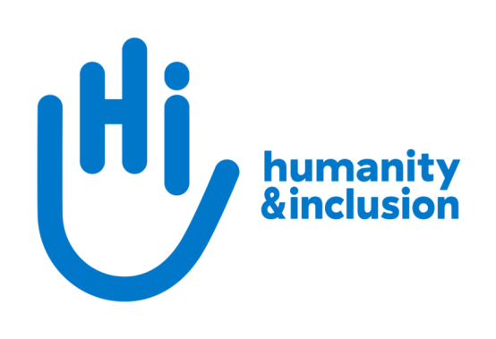

Fundraising Officer:
Legacy and In-Memory Giving

Application pack

A child taking an active part in a lesson, in an inclusive school, in Rwanda ©J.McGeown/HI

Do you want to improve the lives of people with disabilities and vulnerable people?
Humanity & Inclusion (HI) is an award-winning international development organisation working in situations of poverty and exclusion, conflict and disaster. Our UK team is looking for an enthusiastic and self-motivated fundraiser with the drive to grow income from legacies. If you are conscientious and donor-focused, with excellent communication and organisational skills and experience in legacy and in-memory giving, then this role could be for you.

This is an exciting and varied role within our Individual Giving and Communications team. Legacies are a key area of growth for HI and you will play a critical role in developing and sustaining this future income, ensuring our vital work continues.

If you are a committed fundraiser, have a keen eye for detail and a proactive, hands-on approach to managing multiple priorities, we’d love you to join our small, friendly team.
About Humanity & Inclusion (HI)

Working alongside people with disabilities and vulnerable populations, we take action and raise awareness in order to respond to their essential needs, improve their living conditions and promote respects for their dignity and fundamental rights.

HI was co-winner of the 1997 Nobel Peace Prize for our campaign for the Mine Ban Treaty. We were also awarded the 2011 Hilton Humanitarian prize in recognition of our contribution to alleviating human suffering and supporting the most vulnerable people.
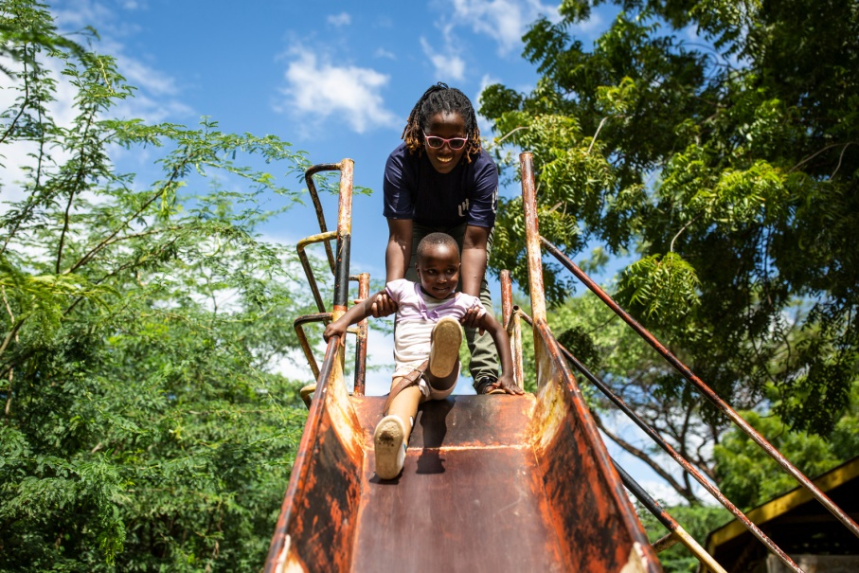
Grace, 5, was born with a congenital disability. She lives in Kakuma refugee camp. Having received a prosthesis from HI, she goes to school and can play like any other child. She wants to be a teacher when she grows up. Here she is with Stella, her HI physiotherapist.

©Patrick Meindhardt/HI

Outraged by the injustice faced by people with disabilities and vulnerable populations, we aspire to a world of solidarity and inclusion, enriched by our differences, and where everyone can live in dignity.

Respect for the rights of people with disabilities has been at the heart of HI’s approach since it was founded in 1982. Over forty years on, our organisation is still working and fighting around the world to improve the living conditions of people with disabilities and other vulnerable people and to ensure that their fundamental rights are respected.

About Humanity & Inclusion UK (HI UK)

HI UK is a member of the Humanity & Inclusion Network, which is comprised of a Federation and eight national associations. As part of the Network, HI UK works towards a common strategy while maintaining a distinct identity as a British organisation. The Federation is responsible for implementing the Network’s social missions in around fifty countries. It operates under the names “Humanity & Inclusion” or “Handicap International”, depending on the country.

HI has an ambitious delivery plan in the UK, as part of our 2016-25 strategy, For More Solidarity and Inclusion in the World.

Equal opportunities policy

HI UK is committed to diversity and inclusion. We recognise that discrimination shapes the opportunities that many people have in society and that people have different needs in order to realise their full potential. Addressing this requires organisations to be proactive in creating environments that encourage the inclusion and development of all. Though we still have a long way to go, inclusion is central to our identity at HI UK and we are strongly committed to the continuous work that it requires.

We are particularly interested in hearing from candidates with disabilities and/or from minority ethnic backgrounds to help make us more representative. If you have a disability and meet the minimum requirements for the role, we will guarantee you an interview.

Employee benefits

- All full-time employees are entitled to 28 days’ holiday per year in addition to UK public holidays.

- Training and development opportunities are open to all staff and will be provided in order to support them to fulfil their roles.

- We value all our employees and strive to support them in their professional lives. This includes offering flexible-working opportunities, including home-working and flexible hours.

- We offer a competitive workplace pension scheme, matching contributions up to 6% of gross salary.

- We are positive about employing persons with disabilities and are proud to be accredited as a Disability Confident Employer.

- We offer a Worklife Support Employee Assistance Programme, which provides confidential information, support and counselling.

- We strive to create a diverse and inclusive working environment and we are constantly looking at ways to improve our policies, processes and culture.

- Our office is conveniently located in London SE1 with great transport links to Waterloo, Blackfriars, London Bridge, and the London Underground.

JOB DESCRIPTION

1. JOB TITLE Fundraising Officer: Legacy and In-Memory Giving

2. ORGANISATION Humanity & Inclusion UK (HI UK)

3. SALARY AND HOURS £36,400 per annum / 37.5 hours a week

4. REPORTING TO Individual Giving & Communications (IGC) Team Manager; Fundraising Manager

5. DURATION Full-time permanent contract

6. LOCATION Based in London (SE1) with some remote working
The applicant must have the right to work in the UK.

7. BACKGROUND INFORMATION AND PURPOSE OF THE POST

As part of our ambitious plans in the UK, we aim to achieve a step-change in private fundraising, taking a donor-centred approach, developing our digital fundraising and running multi-channel campaigns. Contributing to this, you will support the IGC Team Manager and Fundraising Manager to develop and run our legacy fundraising activities.

You will be responsible for developing a legacy and in-memory strategy for HI UK, as well as the running the administration, marketing and stewardship relating to legacy prospects and pledgers.

You will ideally have previous experience of managing legacy case files or be able to show you have an eye for detail and can develop your knowledge quickly.

8. MAIN DUTIES AND RESPONSIBILITIES

Legacy Marketing
- Work alongside the Fundraising Manager to develop a legacy proposition and communication strategy.
- Design and implement legacy and in-memory marketing and stewardship activities.
- Develop multi-channel marketing collateral, including copywriting and design.
- Proactively seek out opportunities to improve the quality of legacy and in-memory giving, monitoring the market and sector trends, and making recommendations to the Fundraising Manager.

Stewardship
- Manage the administration for legacy enquirers and pledgers.
- Review case files on a regular basis and ensure HI UK receives gifts in a timely manner.
- Design, deliver and continually improve multi-channel stewardship journeys for new and existing legacy and in-memory supporters.
- Create engaging stewardship materials with personalised, sensitive and meaningful content.
- Cultivate relationships and ensure appropriate thanking and ongoing stewardship across various platforms.
- Source and develop case studies to use across the legacy and in-memory programme.
- Use insight from audience feedback and previous results to focus on journeys that increase average values and long-term support.

Reporting
- Produce regular reports on marketing activities and stewardship performance, as well as monitoring financial and non-financial key performance indicators.
- Analyse results against targets, identify trends and make recommendations.
- Contribute to continuous improvement through applying test and learn principles across all activities.

Other
- Work with the Major Giving and Individual Giving & Communications teams, effectively briefing them on legacy campaigns and activities.
- Develop internal training and materials to help staff raise awareness of legacy giving.
- Maintain and develop knowledge of applicable law and its application in legacy case management, to include Charity Commission rules and guidance.
- Ensure confidentiality and best practice is adhered to throughout all work, in line with HI UK’s policies and procedures, the Fundraising Regulator, GDPR and relevant codes of practice.
- Cultivate effective relationships with agencies and suppliers.
- Any other activities commensurate with the level of the post, as may be required.

Conduct and safeguarding

Respect and dignity of all the people we support and come into contact with are at the heart of HI’s approach. All employees, volunteers (including trustees), partners, suppliers and consultants working with HI UK are expected to adhere to our Code of Conduct and related policies.

Our commitment to safeguarding means we seek to ensure that no harm comes to people as a result of contact with the organisation’s programmes, operations or people. This means ensuring the safety and protection of groups, including children and vulnerable adults, with whom the organisation is in contact, establishing safe and respectful workplaces that are free from harassment, abuse and discrimination, and maintaining HI’s reputation and high standards by preventing, addressing and learning from instances of wrongdoing.

This post is Safeguarding Level 1, which means no DBS check is required (unless the content of the post changes).

9. PERSON SPECIFICATION
ESSENTIAL
Demonstrable experience of delivering legacy marketing activities or relevant marketing experience
Excellent attention to detail
Strong planning and organisational skills
Excellent written and verbal communication skills and a track record of producing high-quality content
Experience of providing timely, sensitive and inspiring supporter stewardship communications that contribute to building relationships
Experience of delivering campaigns and a proven track-record of meeting or exceeding targets across a range of channels or products
Ability to work in a complex, demanding environment while remaining focused on delivering results
Commitment to creating and maintaining an inclusive and protective environment for everyone that comes in contact with the organisation
DESIRABLE
Knowledge and experience of charity legacy administration including a Certificate in Charity Legacy Administration or similar relevant qualification
Experience of using a relationship database to support, inform and report on fundraising and stewardship activities
French-language proficiency
Experience of working in an international multi-cultural charity/organisation
Lived experience of disability or from one of our countries of operation

APPLICATION PROCESS

To apply for this role, please send your CV and a covering letter, along with the diversity monitoring form, by email or post.

By email: recruitment.uk@hi.org
By post: Humanity & Inclusion UK (Recruitment), 9 Rushworth Street, London SE1 0RB

If you disclose a disability during your application process and you meet the minimum criteria for the role, we will contact you to discuss any reasonable adjustment you might need at the interview. However, if you have not disclosed, please be aware that any candidate invited for interview will be asked if any reasonable adjustments are needed.
If you wish to disclose a disability please do so in your covering letter.

Closing date: Monday 3rd July 2023 11.59pm
Interviews are planned for the week of 10th July

For further information, please contact Humanity & Inclusion UK on 0870 774 3737 or by email at recruitment.uk@hi.org.

